**Vy Bui**

**Homework 3**

**ENGR652**

**Problem 1**

clear,clc,close all;

[X,Y] = meshgrid(-10:.05:10);

% R = sqrt(X.^2 + Y.^2) + eps;

% Z = sin(R)./R;

Z = sinc(X).*sinc(Y);

figure, mesh(X,Y,Z), axis tight;

out = imlin2( Z, 0, 255);

figure, im_Z = image(out), colormap(gray), axis tight;

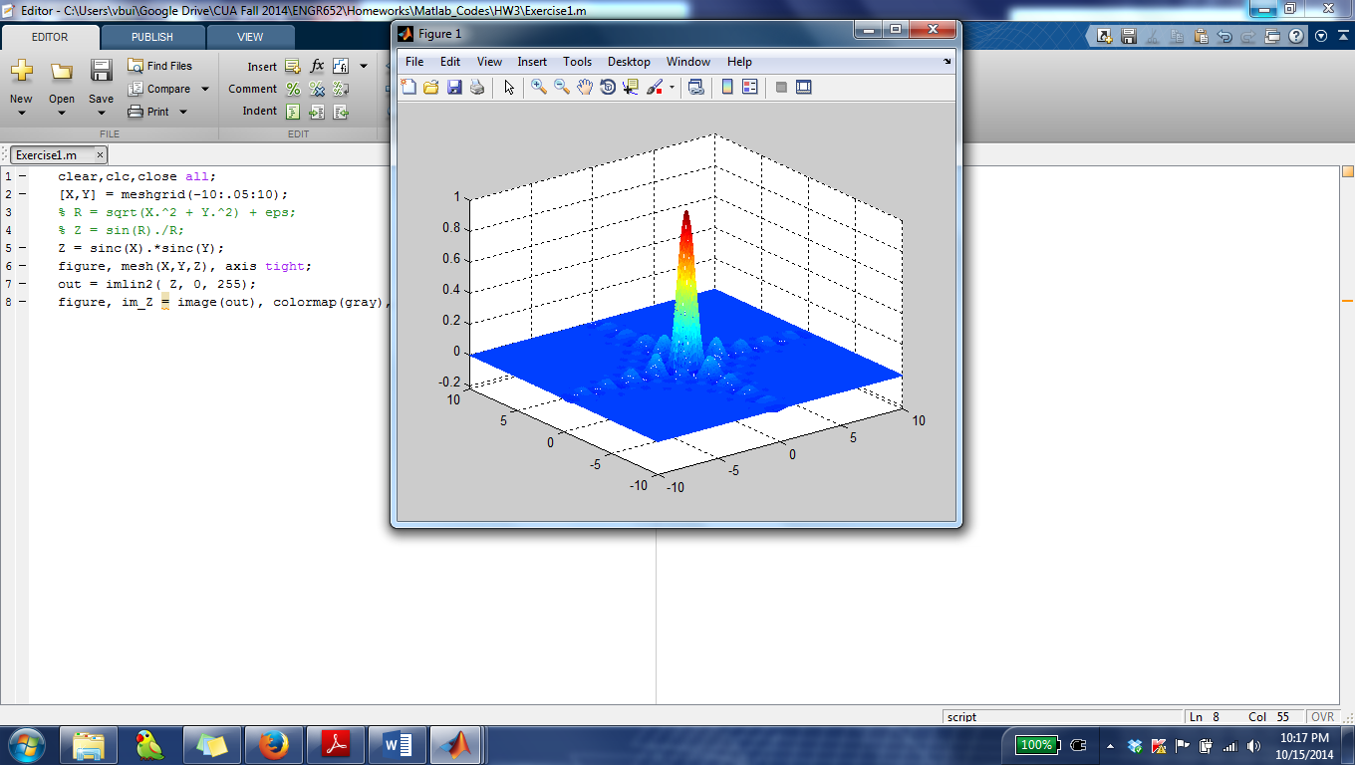

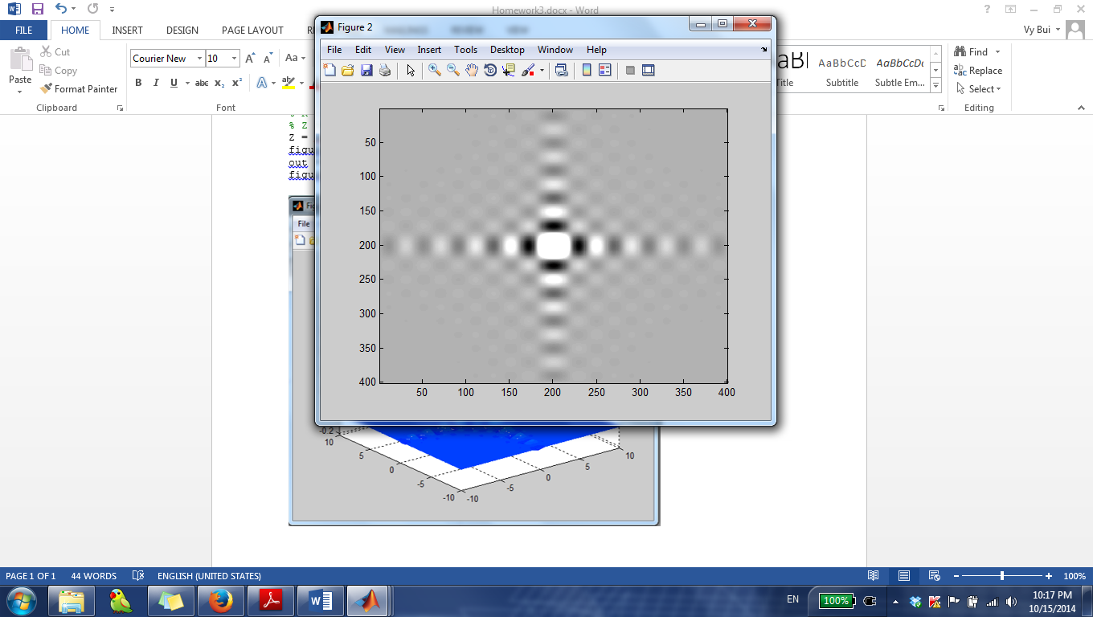

**Problem 2**

%% Rect case

clear, clc, close all;

% [X,Y] = meshgrid(-5:.01:5);

% widthA = 1;

% widthB = 2;

% rectA = 0.5*(sign(X/widthA + 0.5) - sign(X/widthA - 0.5));

% rectB = 0.5*(sign(Y/widthB + 0.5) - sign(Y/widthB - 0.5));

% Z = rectA.*rectB;

% figure, mesh(X,Y,Z);

[X,Y] = meshgrid(-3:.01:3);

widthA = 1;

rectA = rectpuls(X,widthA).*rectpuls(Y,widthA);

figure, mesh(X,Y,rectA); title('rectA'), axis tight;

widthB = 2;

rectB = rectpuls(X,widthB).*rectpuls(Y,widthB);

figure, mesh(X,Y,rectB); title('rectB'), axis tight;

conv2D_AB = conv2(rectA, rectB,'same');

figure, mesh(X,Y,conv2D_AB), title('Conv2D of rectA and rectB'), axis tight;

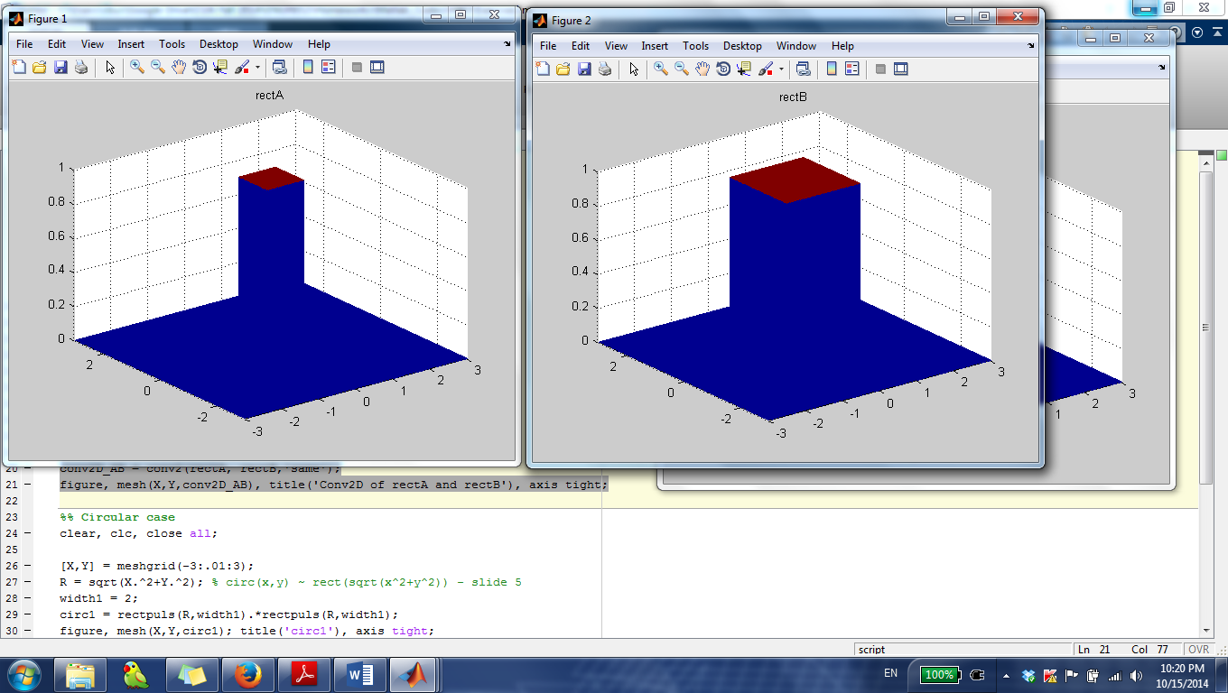

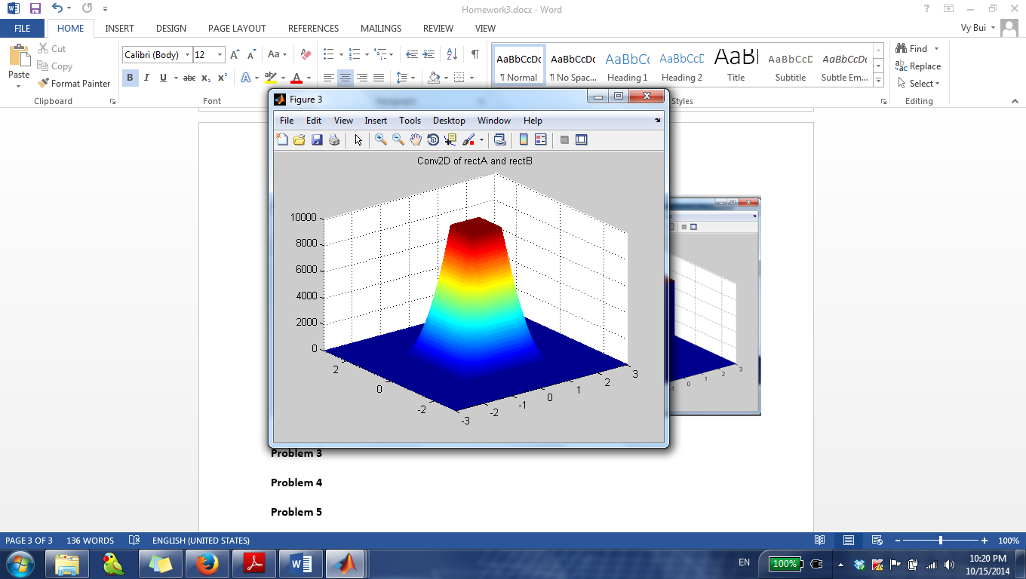

%% Circular case

clear, clc, close all;

[X,Y] = meshgrid(-3:.01:3);

R = sqrt(X.^2+Y.^2); % circ(x,y) ~ rect(sqrt(x^2+y^2)) - slide 5

width1 = 2;

circ1 = rectpuls(R,width1).*rectpuls(R,width1);

figure, mesh(X,Y,circ1); title('circ1'), axis tight;

width2 = 2;

circ2 = rectpuls(R,width2).*rectpuls(R,width2);

figure, mesh(X,Y,circ2); title('circ2'), axis tight;

conv2D_circ = conv2(circ1, circ2,'same');

figure, mesh(X,Y,conv2D_circ), title('Conv2D of circ1 and circ2'), axis tight;

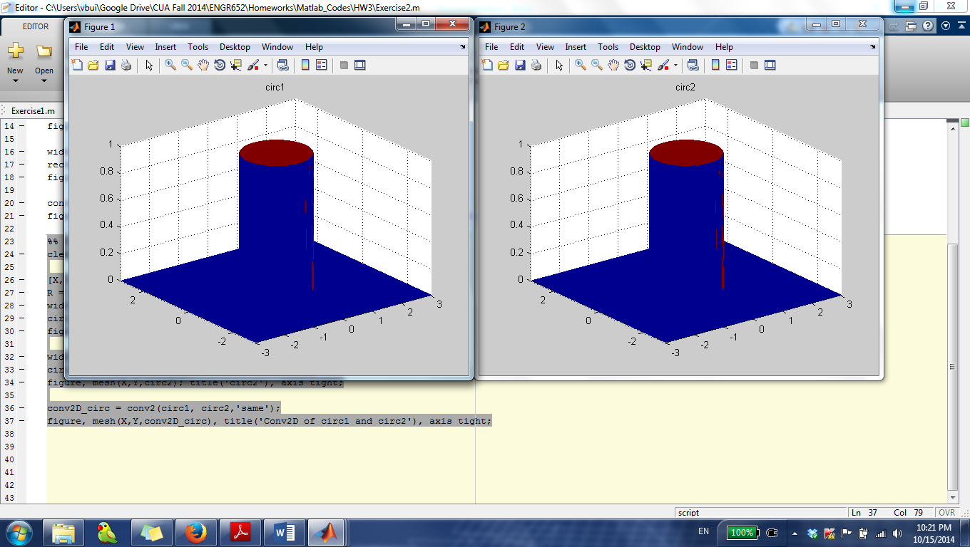

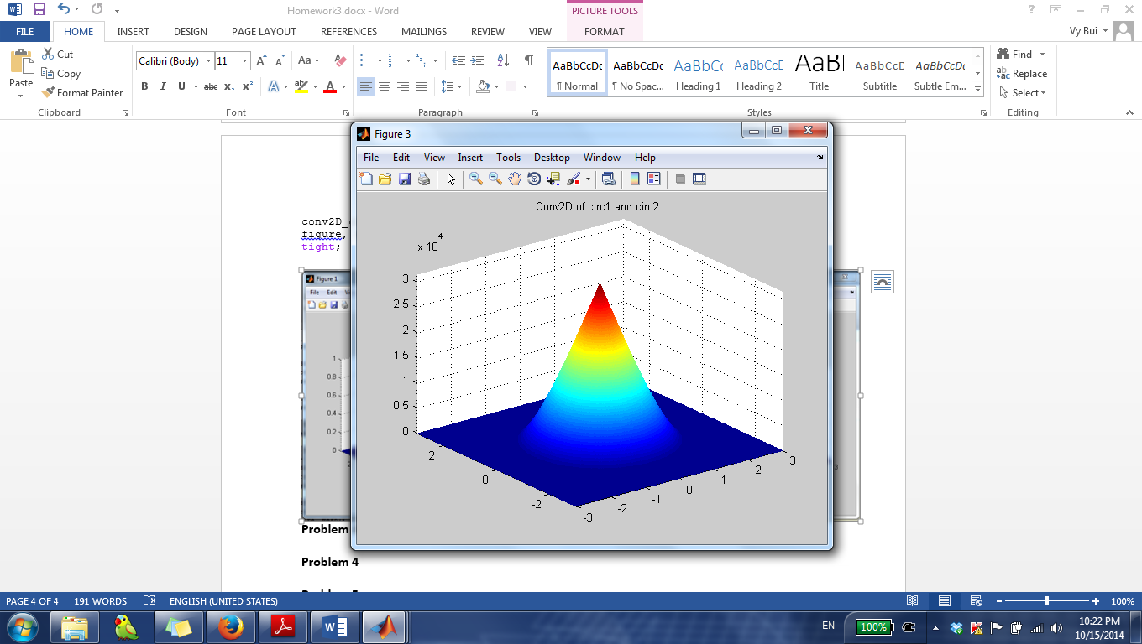

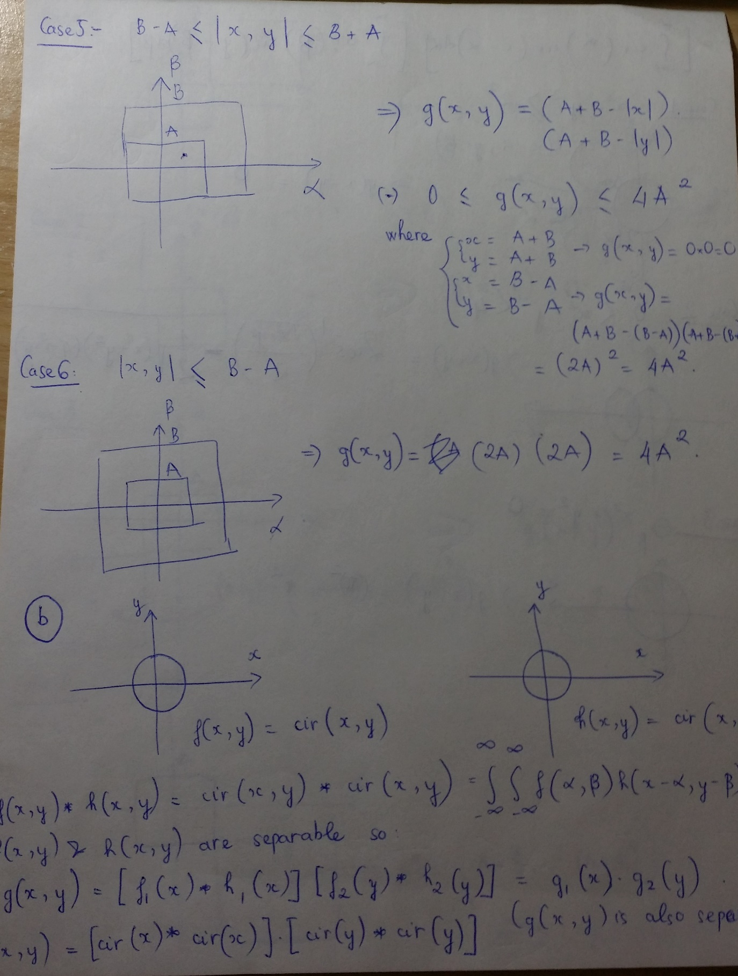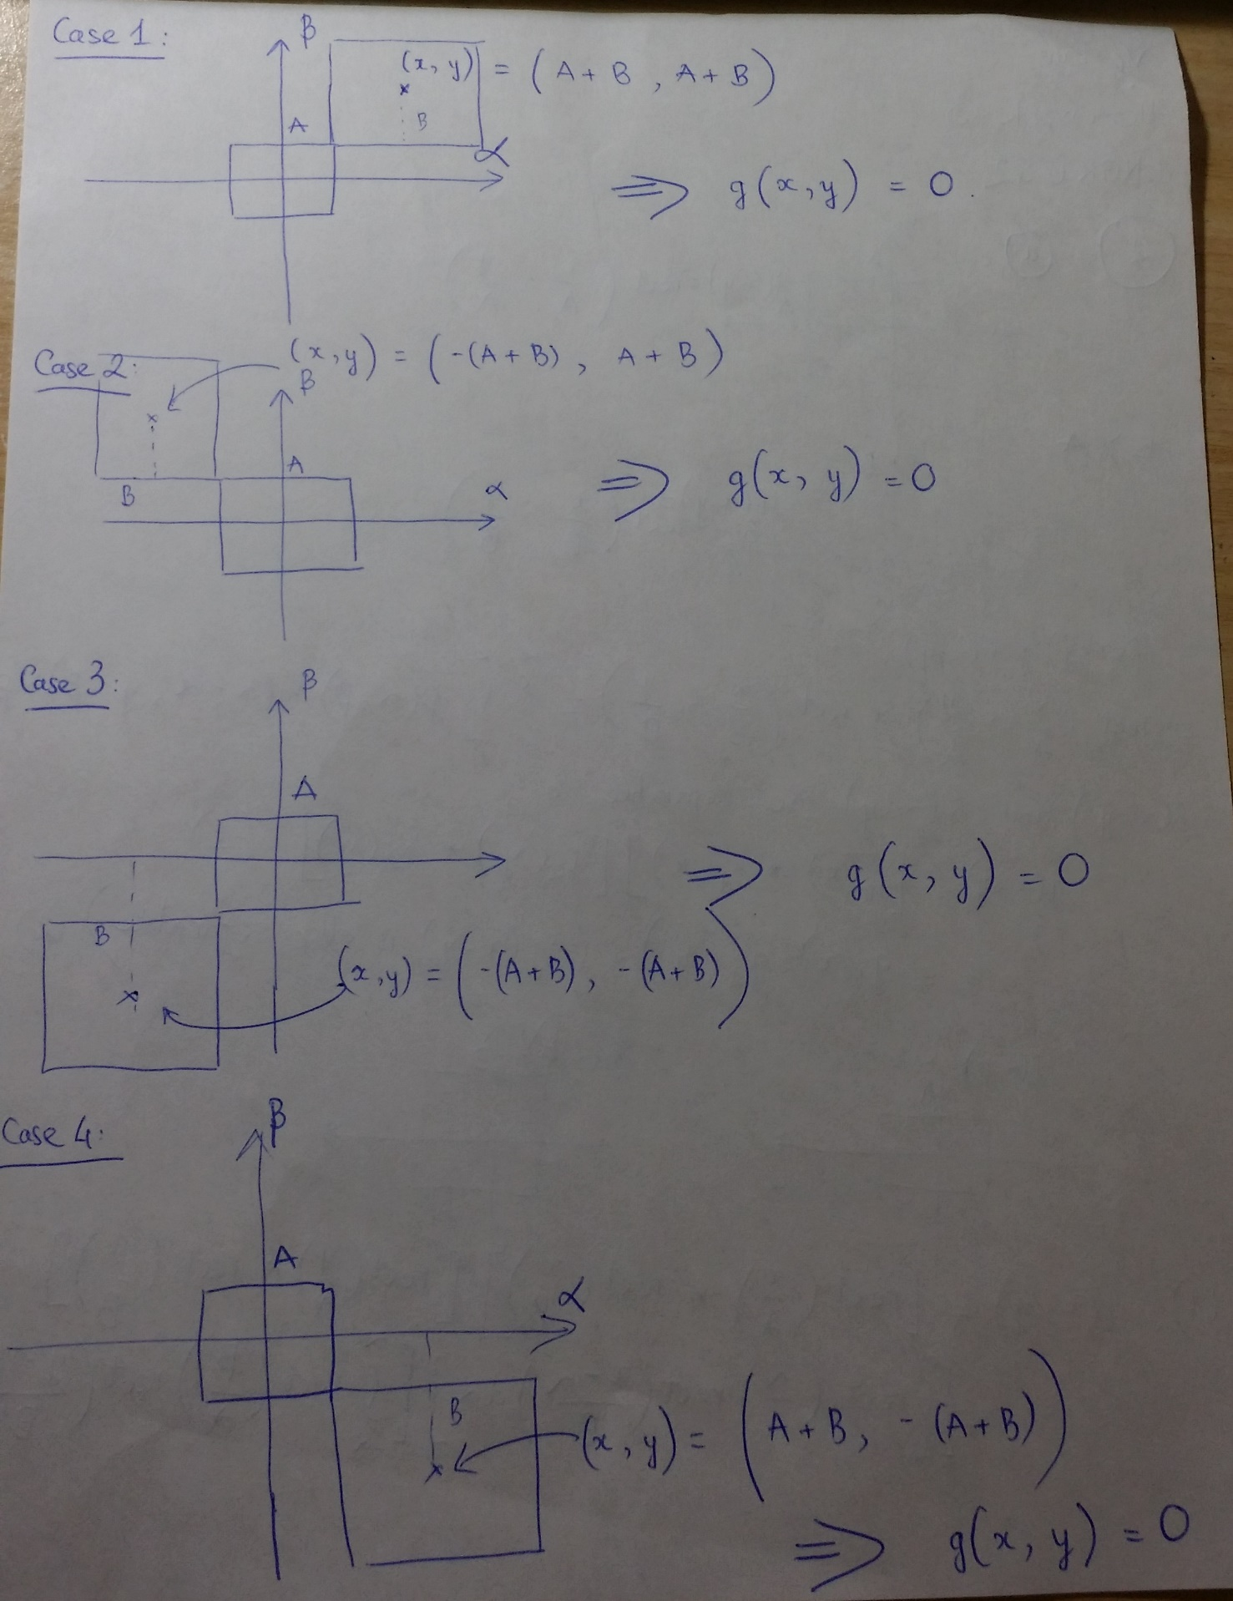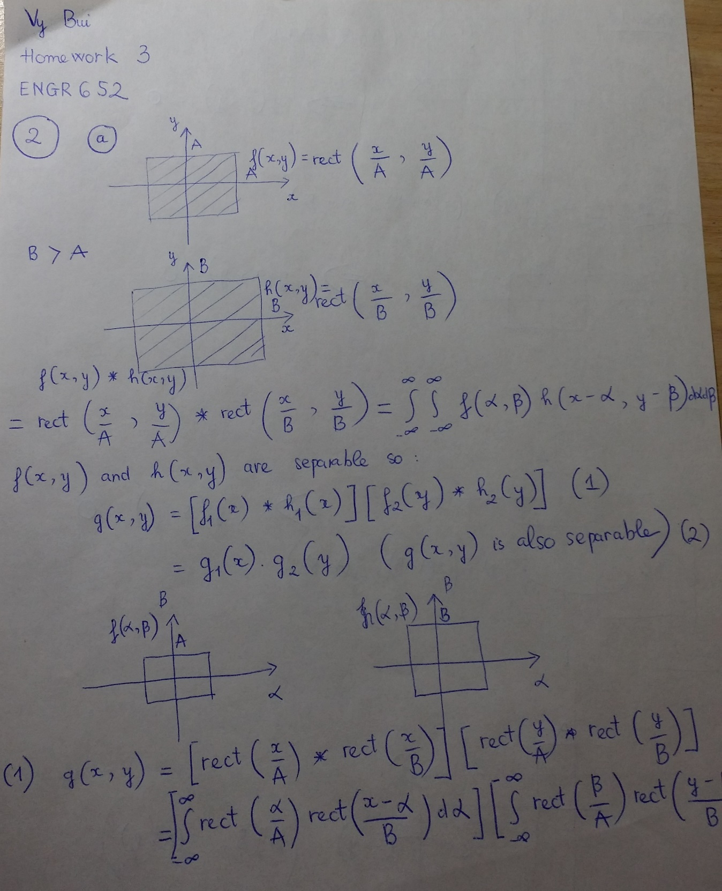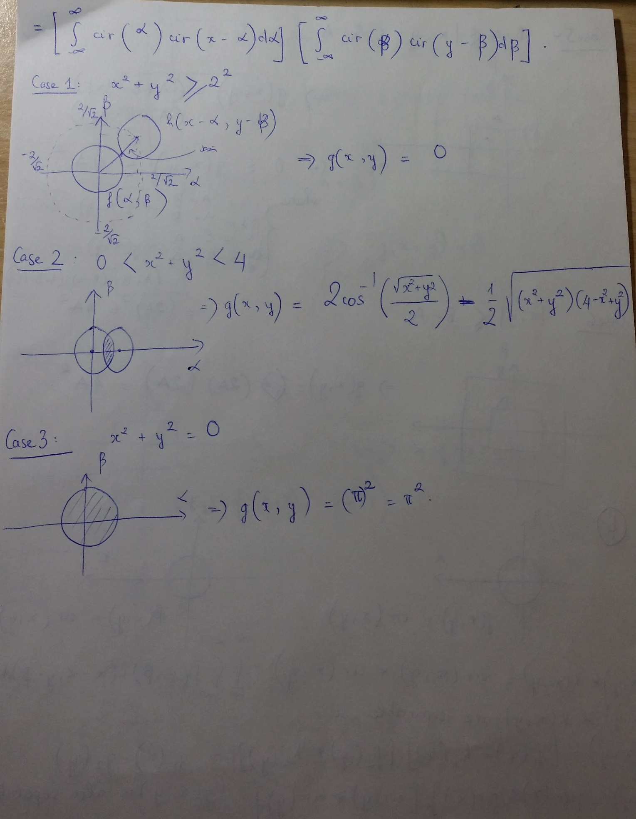

**Problem 3**

%% a

clc, clear, close all;

delta_x=0.01;

delta_y=0.01;

x=-5:delta_x:5;

y=-5:delta_y:5;

N=length(x);

[X,Y] = meshgrid(x,y);

f = cos(pi*X);

figure, mesh(X,Y,f), colormap(gray(256)), view(0,90), title('f(x,y) = cos(\pix)'), xlabel('x'), ylabel('y'), zlabel('f(x,y)');

F = fft2(f);

a=1/(2*delta_x);

b=1/(2*delta_y);

u=[-a:2*a/N:a-2*a/N]';

v=[-b:2*b/N:b-2*b/N]';

figure, imagesc(u,v,fftshift(abs(F))), colormap(gray), title('F(u,v) Magnitude'), xlabel('u'), ylabel('v'), axis tight;

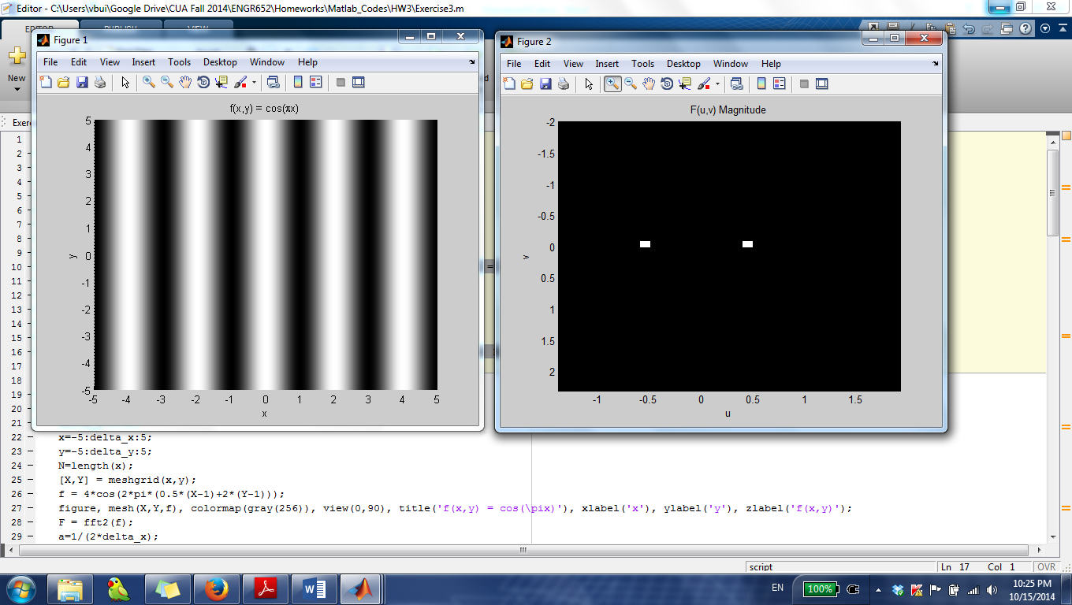

%% b

clc, clear, close all;

delta_x=0.01;

delta_y=0.01;

x=-5:delta_x:5;

y=-5:delta_y:5;

N=length(x);

[X,Y] = meshgrid(x,y);

f = 4*cos(2*pi*(0.5*(X-1)+2*(Y-1)));

figure, mesh(X,Y,f), colormap(gray(256)), view(0,90), title('f(x,y) = cos(\pix)'), xlabel('x'), ylabel('y'), zlabel('f(x,y)');

F = fft2(f);

a=1/(2*delta_x);

b=1/(2*delta_y);

u=[-a:2*a/N:a-2*a/N]';

v=[-b:2*b/N:b-2*b/N]';

figure, imagesc(u,v,fftshift(abs(F))), colormap(gray), title('F(u,v) Magnitude'), xlabel('u'), ylabel('v'), axis tight;

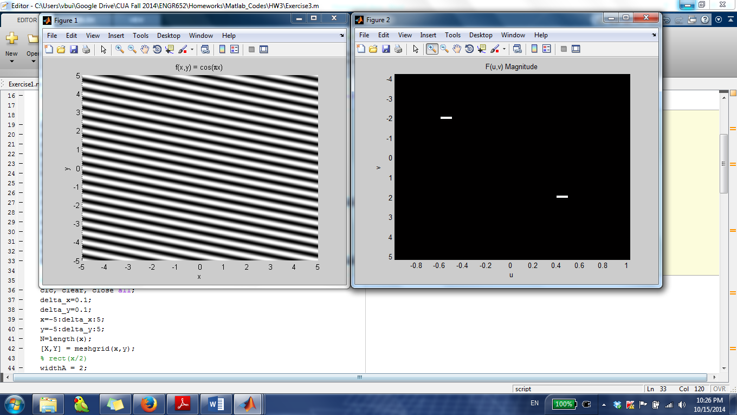

%% c

clc, clear, close all;

delta_x=0.1;

delta_y=0.1;

x=-5:delta_x:5;

y=-5:delta_y:5;

N=length(x);

[X,Y] = meshgrid(x,y);

% rect(x/2)

widthA = 2;

rect = rectpuls(X,widthA);

figure, mesh(X,Y,rect); title('rect'), axis tight;

figure, imagesc(x,y,rect); title('rect - top view'), axis tight;

% comb4(x)*impulse(y)

comb4 = zeros(length(x));

% from middle impulse, calculate the index of the impulses in front and

% after the middle impulse.

row_index_middle_impulse = floor(length(x)/2);

col_index_middle_impulse = floor(length(x)/2);

DELTA = 4/delta_x;

comb4(row_index_middle_impulse,col_index_middle_impulse-DELTA:DELTA:col_index_middle_impulse+DELTA) = 1;

figure, imagesc(x,y,comb4), colormap(gray), title('comb4(x)*impulse(y) - top view'), axis tight;

% f = rect(x/2)*comb4(x).impulse(y)

f = conv2(rect,comb4,'same');

figure, imagesc(x,y,f), colormap(gray(256)), title('f(x,y) = rect(x/2)*comb4(x).dirac(y)'), xlabel('x'), ylabel('y');

F = fft2(f);

a=1/(2*delta_x);

b=1/(2*delta_y);

u=[-a:2*a/N:a-2*a/N]';

v=[-b:2*b/N:b-2*b/N]';

figure, imagesc(u,v,fftshift(abs(F))), colormap(gray), title('F(u,v) Magnitude'), xlabel('u'), ylabel('v'), axis tight;

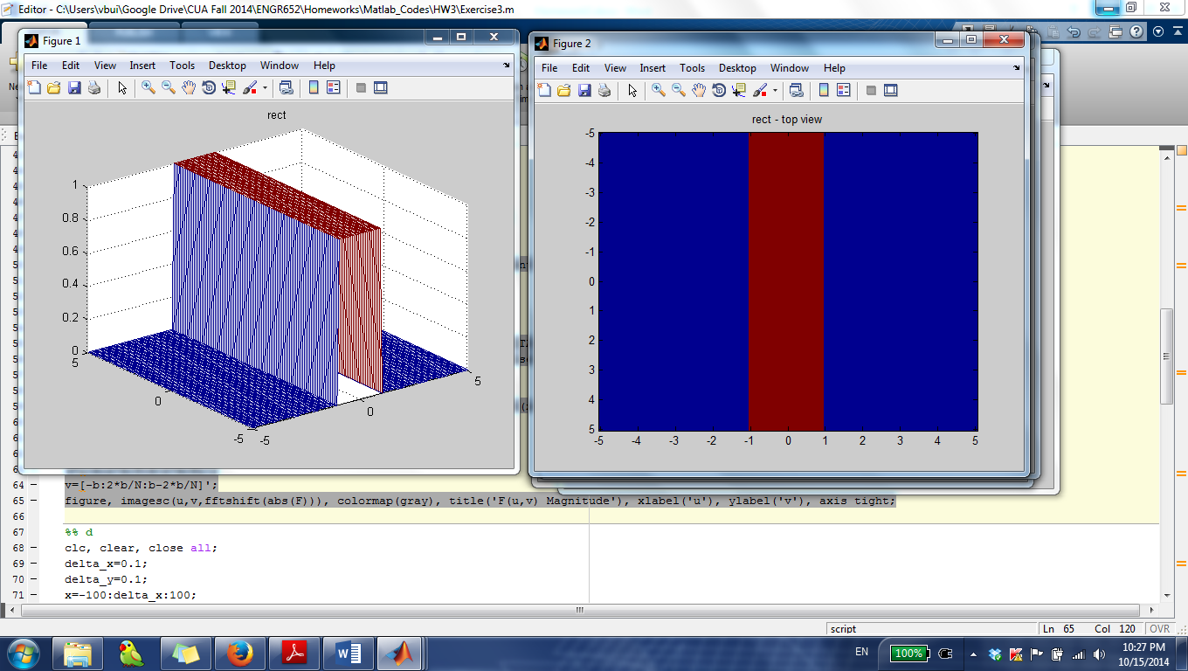

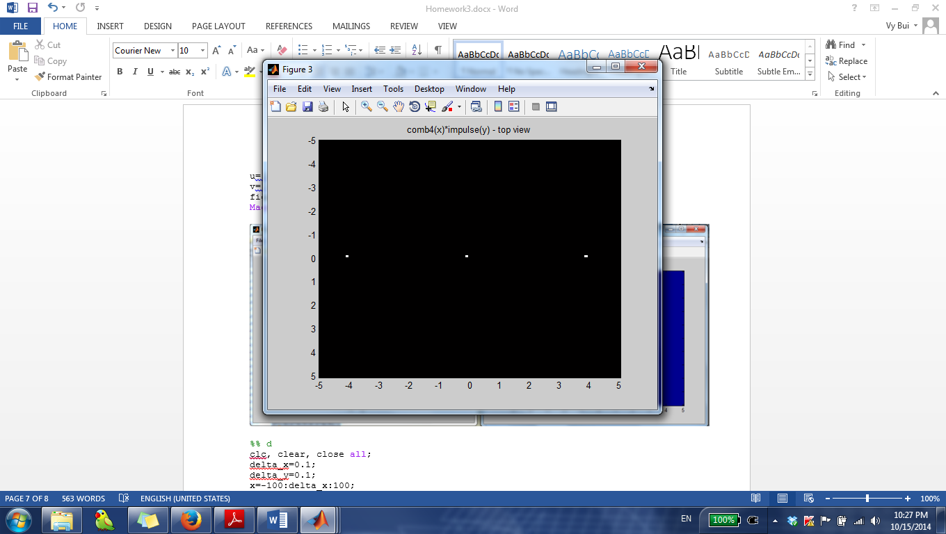

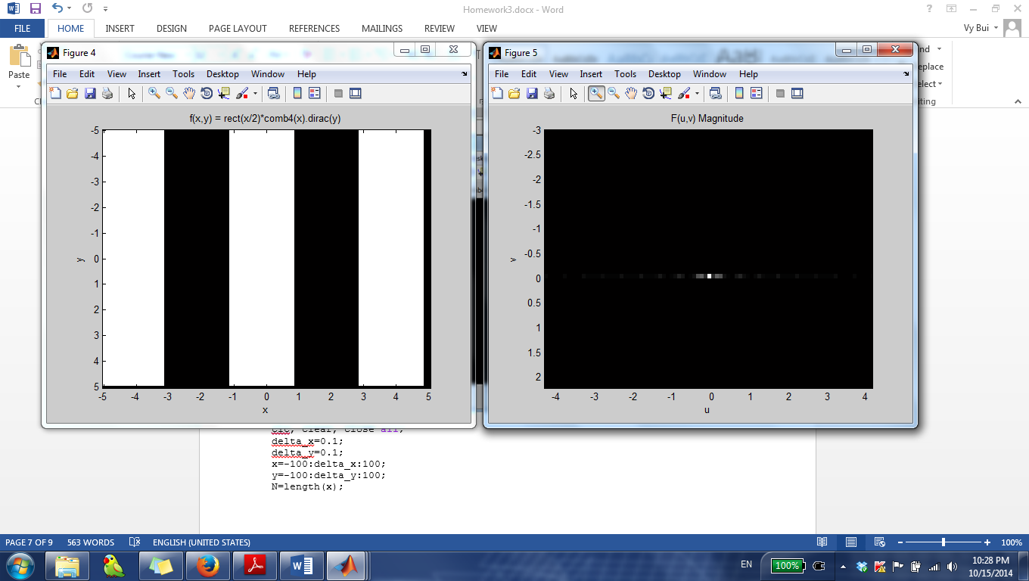

%% d

clc, clear, close all;

delta_x=0.1;

delta_y=0.1;

x=-100:delta_x:100;

y=-100:delta_y:100;

N=length(x);

[X,Y] = meshgrid(x,y);

% rect(x/4-y*sqrt(3)/4)

widthA = 1;

rect = rectpuls(X/4-Y*sqrt(3)/4,widthA).*rectpuls(X/4-Y*sqrt(3)/4,widthA);

figure, mesh(X,Y,rect); title('rect'), axis tight;

figure, imagesc(x,y,rect); title('rect - top view'), axis tight;

% comb8(x)*impulse(y)

comb8 = zeros(length(x));

row_index_middle_impulse = floor(length(x)/2);

col_index_middle_impulse = floor(length(x)/2);

DELTA = 8/delta_x;

comb8(row_index_middle_impulse,col_index_middle_impulse-10*DELTA:DELTA:col_index_middle_impulse+10*DELTA) = 1;

figure, imagesc(x,y,comb8), colormap(gray), title('comb8(x)*impulse(y) - top view'), axis tight;

% f = rect(x/4-y*sqrt(3)/4)*comb8(x)*impulse(y)

f = conv2(rect,comb8,'same');

figure, imagesc(x,y,f), colormap(gray(256)), title('f(x,y) = rect(x/2)*comb8(x).dirac(y)'), xlabel('x'), ylabel('y');

F = fft2(f);

a=1/(2*delta_x);

b=1/(2*delta_y);

u=[-a:2*a/N:a-2*a/N]';

v=[-b:2*b/N:b-2*b/N]';

figure, imagesc(u,v,fftshift(abs(F))), colormap(gray), title('F(u,v) Magnitude'), xlabel('u'), ylabel('v'), axis tight;

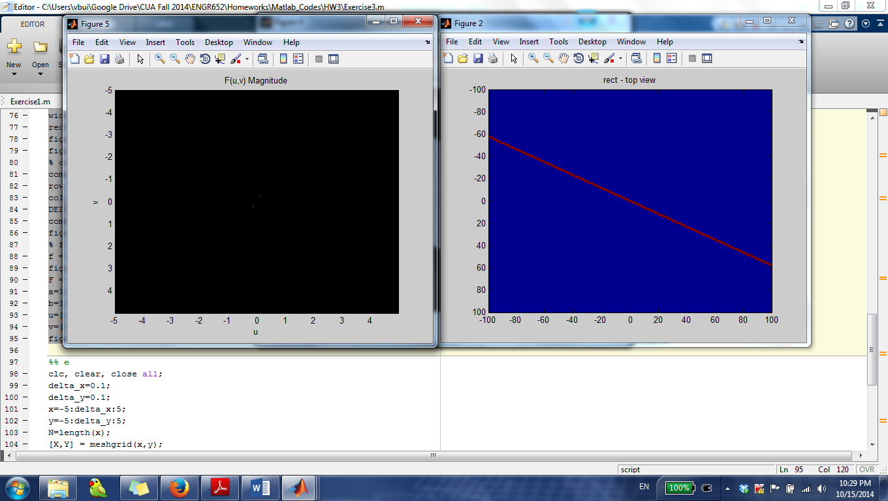

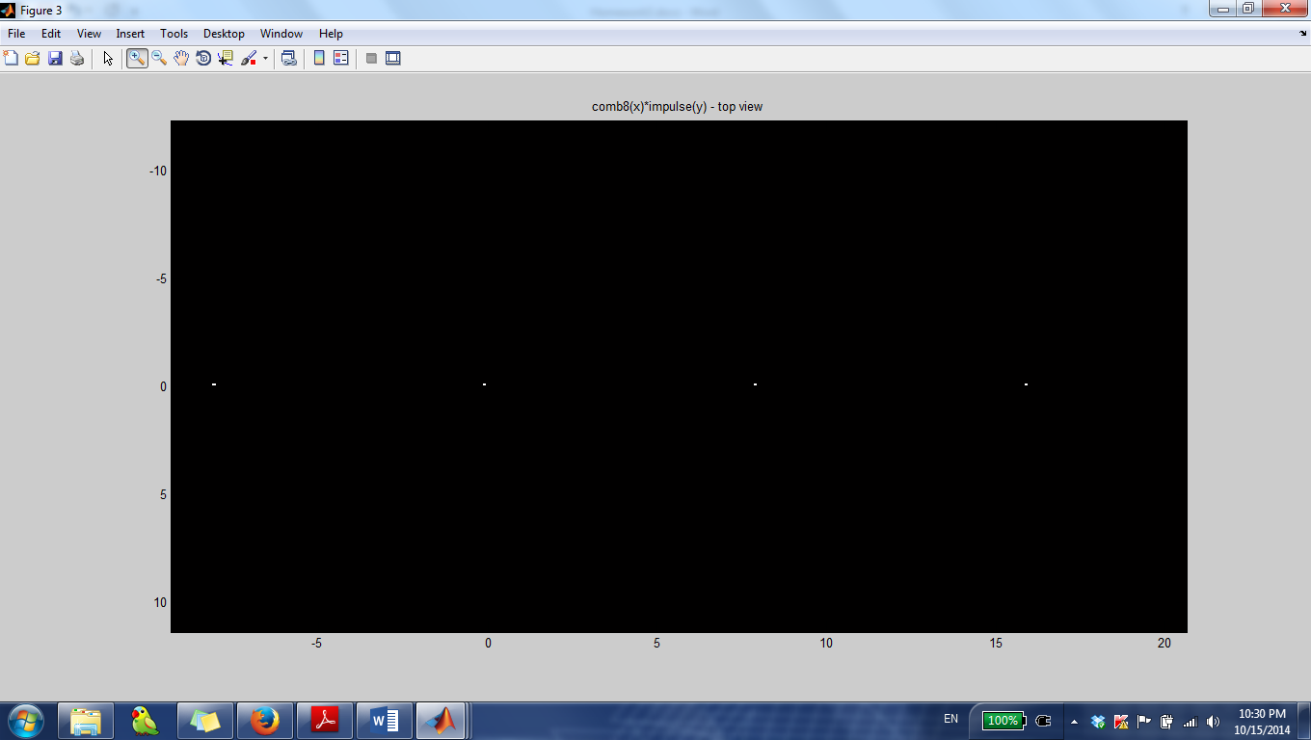

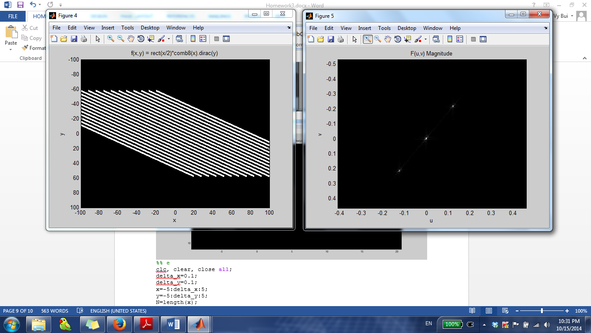

%% e

clc, clear, close all;

delta_x=0.1;

delta_y=0.1;

x=-5:delta_x:5;

y=-5:delta_y:5;

N=length(x);

[X,Y] = meshgrid(x,y);

widthA = 1;

rect = rectpuls(X,widthA).*rectpuls(Y,widthA);

figure, mesh(X,Y,rect); title('rect'), axis tight;

figure, imagesc(x,y,rect); title('rect - top view'), axis tight;

comb22 = zeros(length(x));

row_index_middle_impulse = floor(length(x)/2);

col_index_middle_impulse = floor(length(x)/2);

DELTA = 2/delta_x;

comb22(col_index_middle_impulse-2*DELTA:DELTA:col_index_middle_impulse+2*DELTA,col_index_middle_impulse-2*DELTA:DELTA:col_index_middle_impulse+2*DELTA) = 1;

figure, imagesc(x,y,comb22), colormap(gray), title('comb8(x)*impulse(y) - top view'), axis tight;

f = conv2(rect,comb22,'same');

figure, imagesc(x,y,f), colormap(gray(256)), title('f(x,y) = rect(x/2)*comb8(x).dirac(y)'), xlabel('x'), ylabel('y');

F = fft2(f);

a=1/(2*delta_x);

b=1/(2*delta_y);

u=[-a:2*a/N:a-2*a/N]';

v=[-b:2*b/N:b-2*b/N]';

figure, imagesc(u,v,fftshift(abs(F))), colormap(gray), title('F(u,v) Magnitude'), xlabel('u'), ylabel('v'), axis tight;

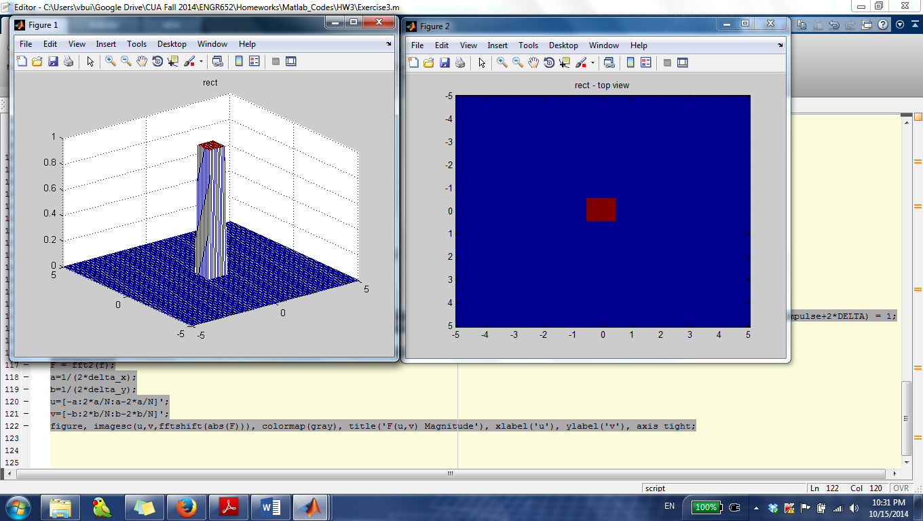

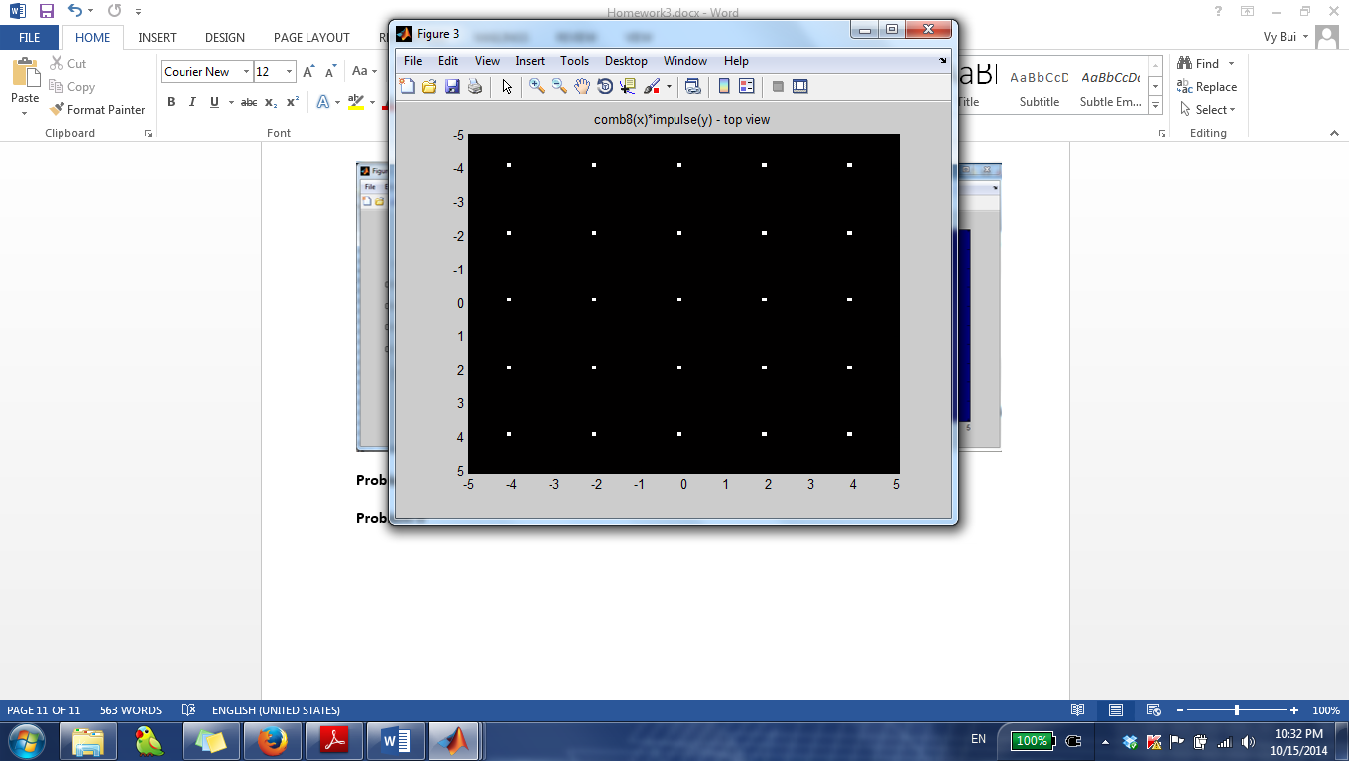

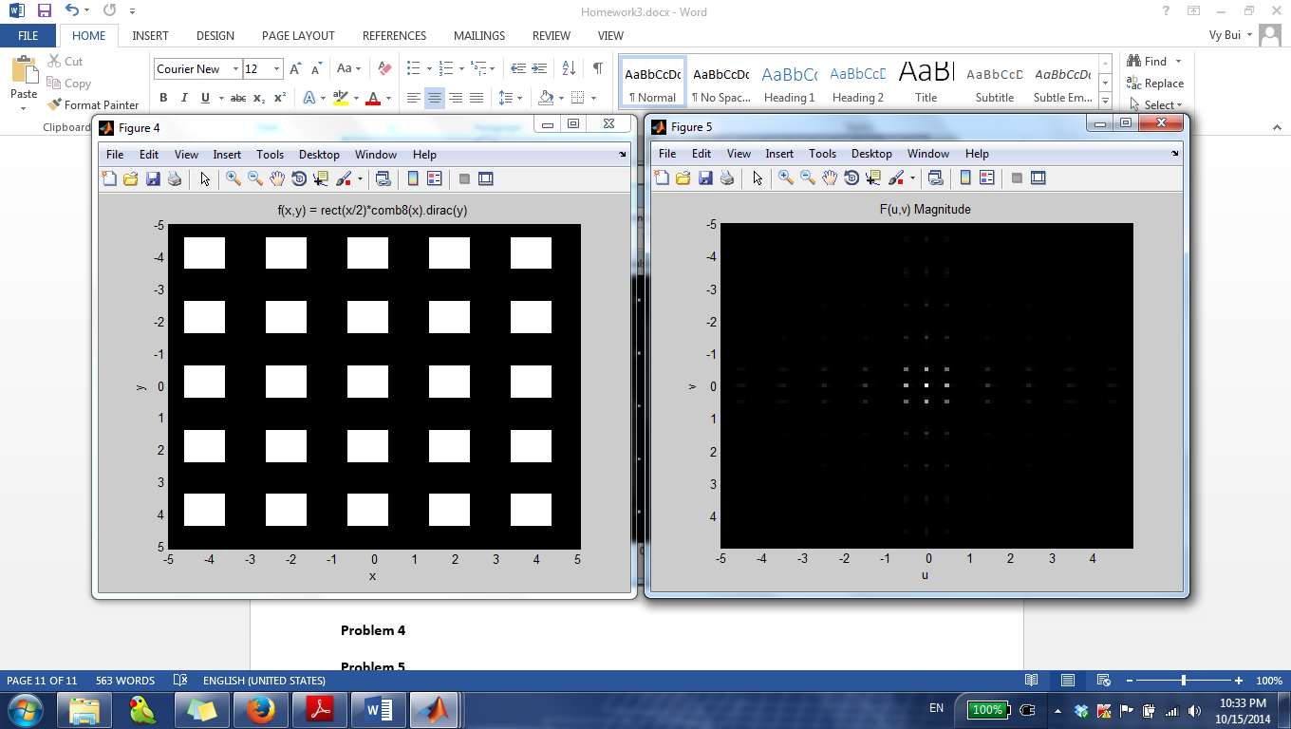

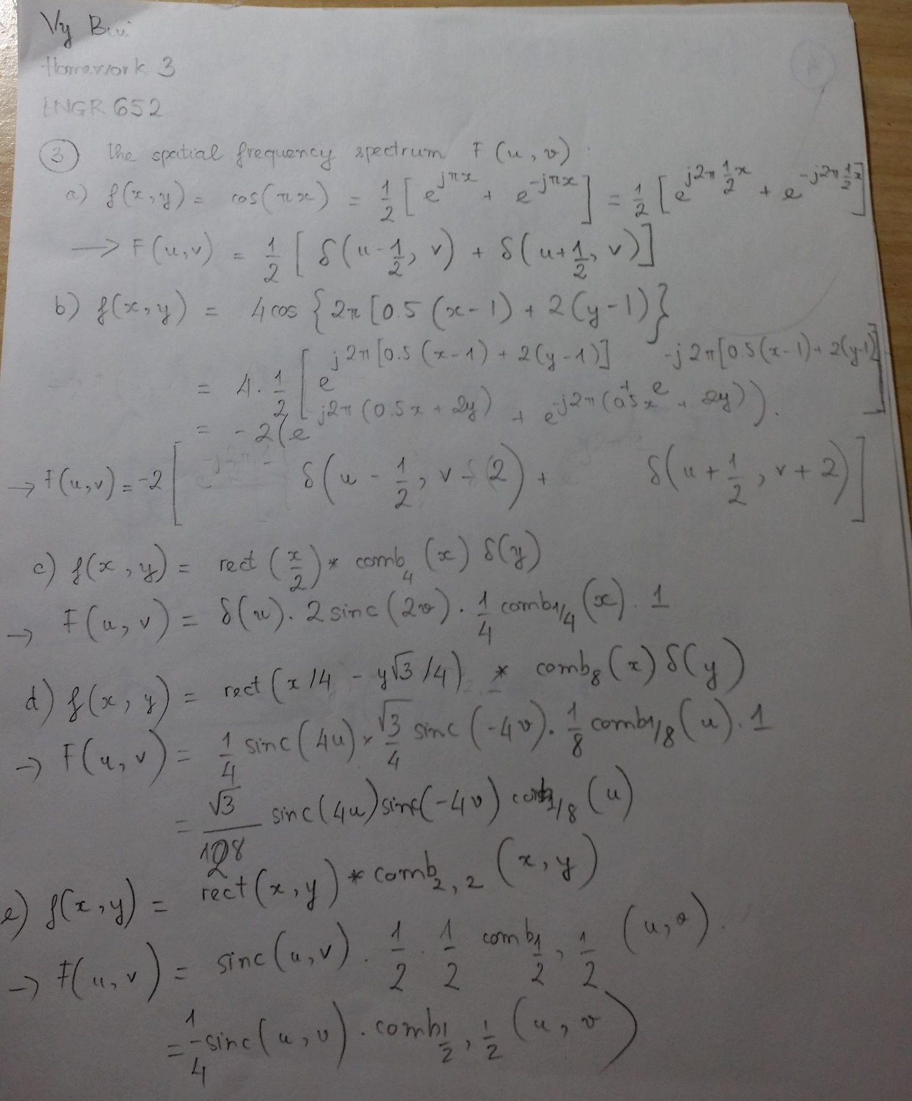

**Problem 4**

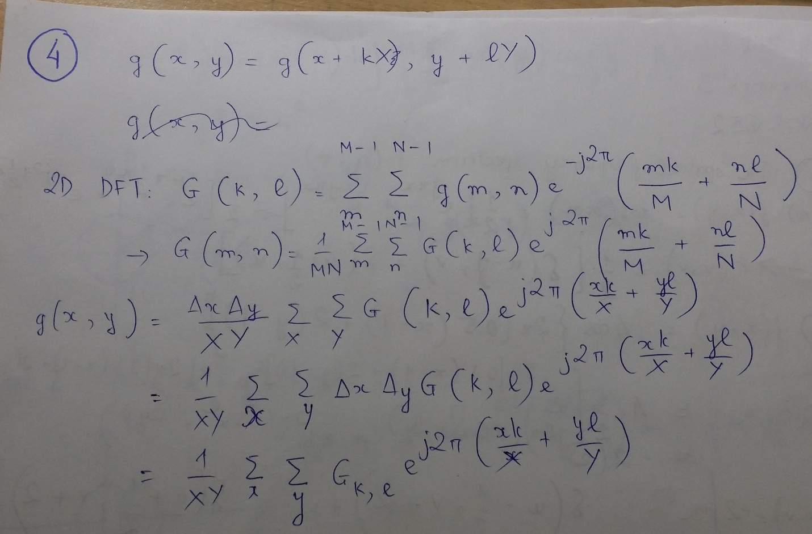

**Problem 5**

%% Exercise 5a

clear, clc, close all;

delta_x=0.1;

delta_y=0.1;

x=-8:delta_x:8;

y=-8:delta_y:8;

N=length(x);

f = (checkerboard(8, 4, 8) > 0.5);

f = double(f);

figure, imagesc(x, y, f), colormap(gray(256));

% Find u,v coordinates

a=1/(2*delta_x);

b=1/(2*delta_y);

u=[-a:2*a/N:a-2*a/N]';

v=[-b:2*b/N:b-2*b/N]';

% fft

F = fft2(f);

figure, imagesc(u,v,fftshift(abs(F))), colormap(gray), title('F(u,v) Magnitude'), xlabel('u'), ylabel('v'), axis tight;

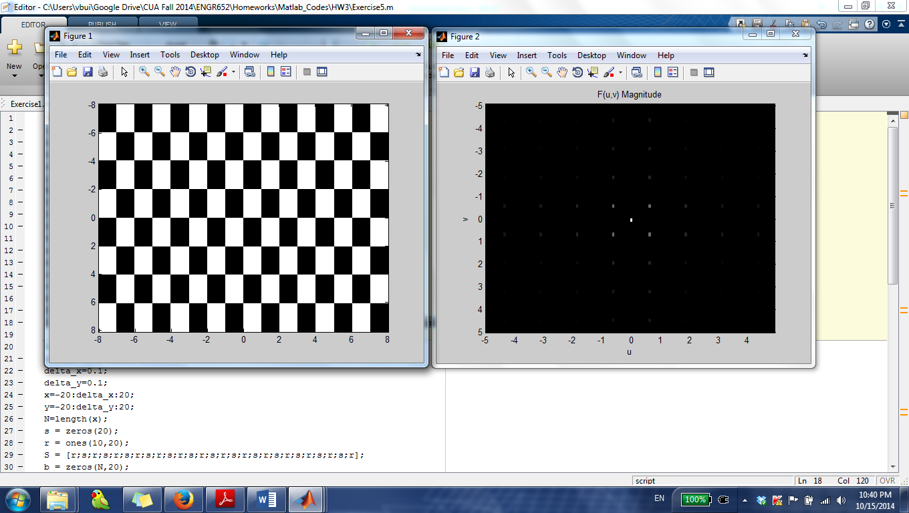

%% Exercise 5b

clear, clc, close all;

delta_x=0.1;

delta_y=0.1;

x=-20:delta_x:20;

y=-20:delta_y:20;

N=length(x);

s = zeros(20);

r = ones(10,20);

S = [r;s;r;s;r;s;r;s;r;s;r;s;r;s;r;s;r;s;r;s;r;s;r;s;r;s;r];

b = zeros(N,20);

w = ones(N,10);

Signal = [b w S w b w S w b w S w b w S w b w S w b w S w b w S w];

imagesc(x,y,Signal);

% Find u,v coordinates

a=1/(2*delta_x);

b=1/(2*delta_y);

u=[-a:2*a/N:a-2*a/N]';

v=[-b:2*b/N:b-2*b/N]';

% fft

F = fft2(Signal);

figure, imagesc(u,v,fftshift(abs(F))), colormap(gray), title('F(u,v) Magnitude'), xlabel('u'), ylabel('v'), axis tight;

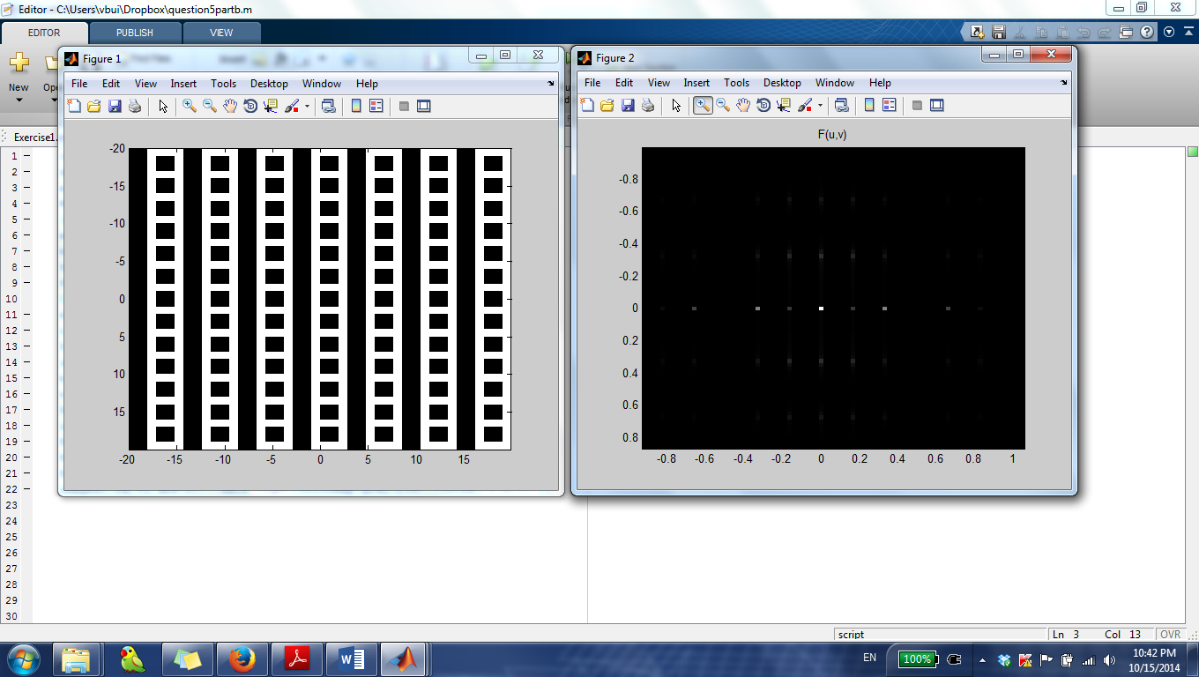

%% Exercise 5c

clear, clc, close all;

delta_x=0.1;

delta_y=0.1;

x=-6:delta_x:6;

y=-6:delta_y:6;

N=length(x);

[X,Y]=meshgrid(x,y);

rect = rectpuls(-X+Y+0.5,1)+rectpuls(-X+Y-4+0.5,1)+rectpuls(-X+Y+4+0.5,1)+rectpuls(-X+Y-8+0.5,1)+rectpuls(-X+Y+8+0.5,1)+rectpuls(-X+Y-12+0.5,1);

figure, mesh(X,Y,rect); title('rect'), axis tight;

figure, imagesc(x,y,rect); title('rect - top view'), axis tight;

% Find u,v coordinates

a=1/(2*delta_x);

b=1/(2*delta_y);

u=[-a:2*a/N:a-2*a/N]';

v=[-b:2*b/N:b-2*b/N]';

% fft

F = fft2(rect);

figure, imagesc(u,v,fftshift(abs(F))), colormap(gray), title('F(u,v) Magnitude'), xlabel('u'), ylabel('v'), axis tight;

